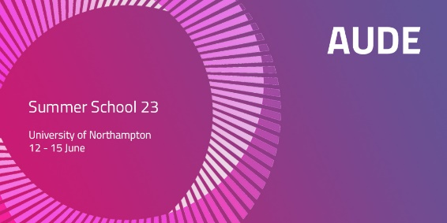
AUDE Summer School 2023

Delegate Session Insights

Introduction.

A pre course questionnaire was circulated to delegates to provide an opportunity for them to express the motivations for attending the programme and what their expectations were from attending. The results of the feedback were then analysed in three-word maps shown below:

Why are you doing this Summer School at this point in time?
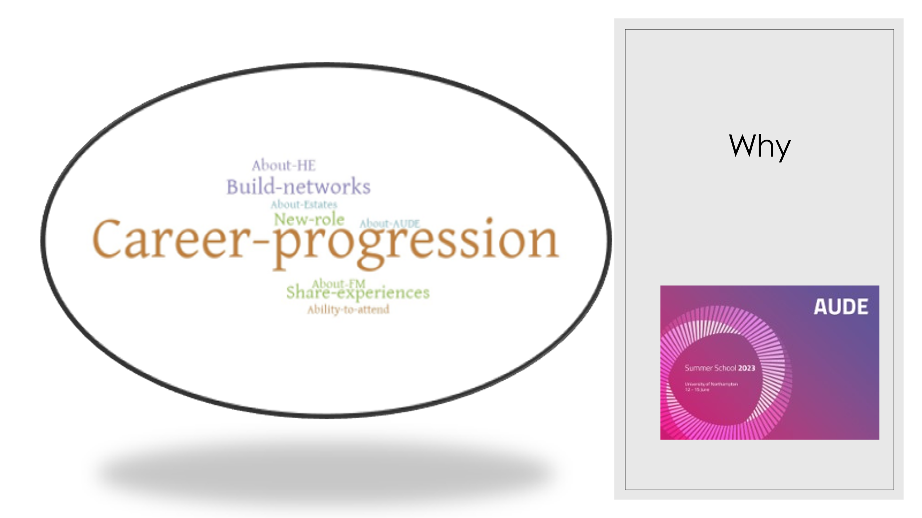

What do you hope to get out of the Summer School?
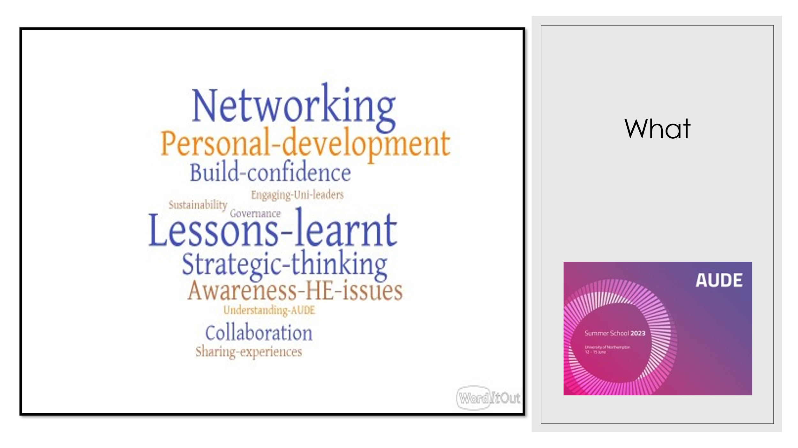
What are your three biggest challenges at work.
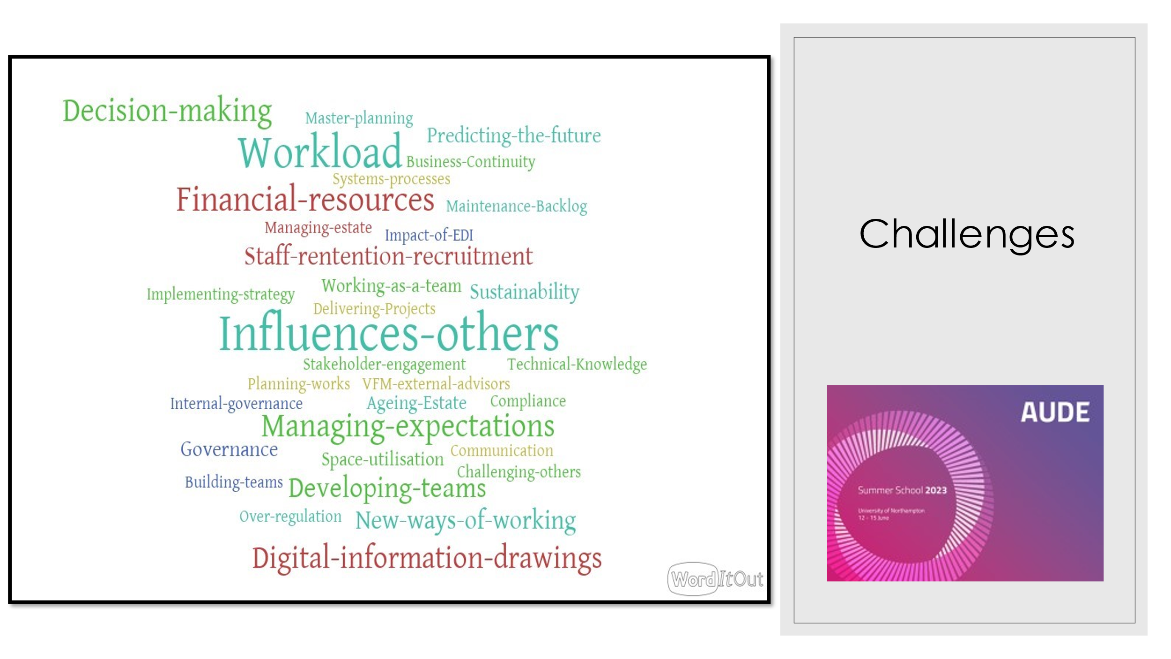
At the beginning of each day delegates spent 30 minutes reflecting on the previous days learning and key takeaways. The summary of feedback from each day is presented below:
AUDE Summer School 2023 Day 1 Insights
Delegates:
- valued the opportunity to share experiences.
- recognise they all have similar problems and challenges.
- appreciated the role business change models can play e.g. Kotter’s Change model https://www.kotterinc.com/methodology/8-steps/
- will investigate further the FM Strategic Tool Kit https://www.iwfm.org.uk/about/the-professional-standards.html
- recognised the tension between achieving sustainability goals and poor space utilisation.
- Questioned how change in space utilisation can be delivered without a fundamental change in universities operating models. AUDE Resources
AUDE Summer School 2023 Day 2 Insights
Delegates:
- found the session on influencing the board insightful. Delegates had a clearer understanding of the importance of preparing the way when seeking decisions from the University Executive and the various committees and board/senate.
- understood that building trust is important and linked this to the developing your personal brand session.
- recognised that it was helpful to create opportunities to meet Board Governors
- several of the presentations including valuable tips on influencing others. The explanation of stakeholder mapping and its application in an estates and facilities context was helpful.
- found examples of the differences between HE’s which were described by delegates insightful.
- appreciated the session on Space Management which they felt recognised the key challenges involved.
- identified a common thread throughout all the days presentations around the value of “engagement” across teams, departments and the University as well as with external stakeholders.
- felt the tips of managing workload were helpful and will take that a way to try. https://www.youtube.com/watch?v=4aD8WG49PY4
- https://www.amazon.co.uk/Getting-Things-Done-Workbook-Productivity
- Identified how promoting the facilities and estates can support collaborative working across the institutions.
- identified that on internal relationships they recognise the importance of finance and estates working collaboratively and the call out on procurement as well.
- thought the call out of energy overspend on a separate budget line was a good tactic given how uncontrollable these costs are in the current external environment on costs.
AUDE Summer School 2023 Day 3 Insights
Delegates:
- learnt how to use the 4-mat model for presentations and report writing http://www.integralleadership.com/bernice-mccarthys-4-mat-system.php
- recognised the importance of using date to influence decision making https://www.tableau.com/learn/articles/data-driven-decision-making
- understood the role of effective collaborative working with IT.
- welcomed the take aways and tips form the How to Hold the Room sessions.
- were impressed with the passion of the University of Northampton’s VC for teaching.
- took away the Bowtie mode for assess risks from the Business Continuity Session. The Bowtie Model.
The session on “How to Hold the Room” included a short workshop where delegates considered what the speaker described as “Status Paradigms”. The table below is a record of the flip charts produced by the delegates.

The Status Paradigms
Expectations | Stressed  Nervous  Neglected  Fearful  Introvert | High Achievements  Inspired  Purpose  Motivated  Visible  Engaged  Valued
 | Discouraged  Unmotivated  Absent  Chaos | Asleep  Frustrated  Unseen  Lazy  Underestimated
 | Support

AUDE Summer School 2023 Day 4 Insights
Delegates:
- felt that the crisis management and strategic planning session were highly relevant to their roles.
- supported the principle that organisations should be prepared for a major incident and took away the key steps to making that happen.
- found both presentations insightful.
- commented that the strategy session was excellent at bringing together several of the themes that have been covered during the programme.
Conclusion
Subject to further delegate feedback, from my perspective I found all the delegates were highly engaged and motivated. In playing back their expectations of the programme delegates informed me that the programme had exceeded their expectations and they felt more empowered and confident.
Mark Q Swales FInstLM
AUDE Summer School Facilitator
markqswales@btinternet.com

